# **UFCF85-30-3 Enterprise System Development**

# **Sprint Review Form**

| Group: | 18 |
| --- | --- |
| Sprint: | 3 |
| Members: | Benedict Ramage-Mangles, Ross Williams, Arjun Binning, Michael Duncan, Matthew Hill |

<<Burn-down Chart>>

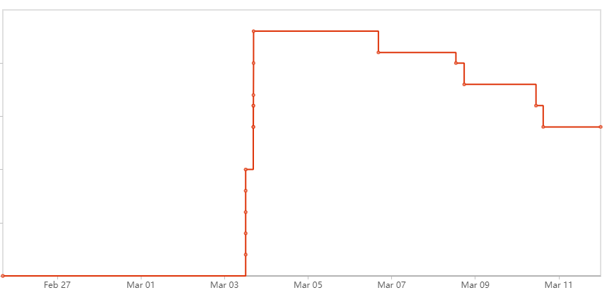

As can be seen, not all of the work allocated was completed in the allocated sprint time. More information can be found in the Sprint Backlog section.

<<Backlog list>>

Sprint Backlog:

**User Story 1: As an Employee, I need to be able to sign into an account so that I can access extra functionality based on role.**

**Tasks to be completed for US1:**

* Create Account Model/Database to store usernames, passwords, and account type (Michael)
* Create Template for Sign in page (Arjun)
* Create Templates for each user to be sent to once signed in
  + Cinema Manager: Add Films page (Ross)
  + Account Manager: View Accounts page (Michael)
  + Club Representative: Make Booking page (Benedict)
* Assign Logic in views.py to link Model to Template (Matt, Ross, Arjun)

As well as the Use Case specified, the tasks rolled over from the previous sprint also require completing.

**Final Sprint Backlog at the end of Sprint 3:**

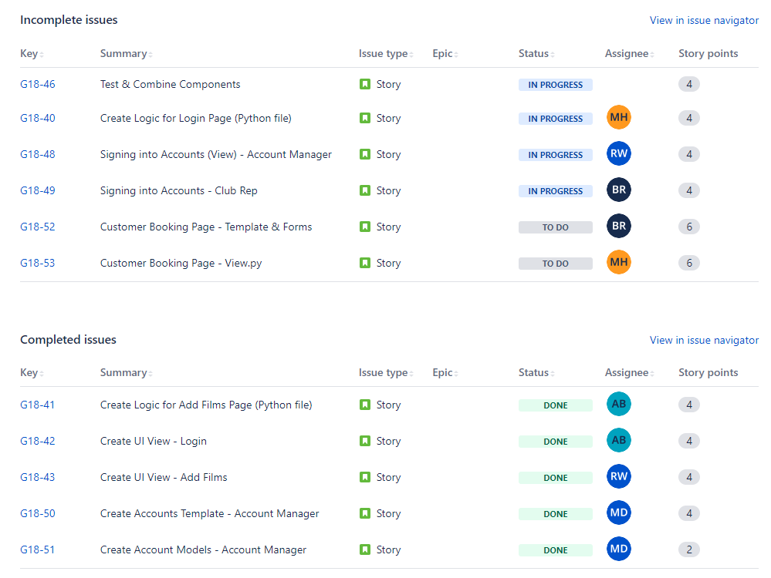

There were a couple of issues for a large part of the sprint which had halted progress; Matt had trouble accessing the GitHub in order to push work onto the project, and Benedict has had some bugs with his code which halted progress. This has been resolved and hope that this will result in smoother progress in the upcoming sprints.

<<Communication Issues>>

The entire group have been communicating well. There have been a few absences to the practical sessions, however we have all caught up via a group call in the week to make up for it.

<Reflections>>

| Task | Person | What Went Well | Needs Work | Comments |
| --- | --- | --- | --- | --- |
| Create Account Models - Account Manager | Michael Duncan | Managed to fully implement the required models with the functionality needed to store all of the required data. | Changes had to be made to the initial design in order to fully satisfy the criteria effectively. The Transaction database has been split into two, with individual tickets being separated into the Booking model. | More consideration to be made to initial designs to ensure that the product will work effectively. |
| Create Account Template - Account Manager | Michael Duncan | Created a page where the Account Manager is able to search for individual Club Reps by their id, | I hoped to manage to search via a drop down menu for convenience, however I was having issues, and therefore is only searchable by manually entering the customer_id for the moment. | If there is time I would like to implement the drop down menu, for better usability. |
| UI View - Add Films & Account Manager sign in | Ross Williams | Base template for the add film page has been made. |  |  |
|  |  |  |  |  |
|  |  |  |  |  |

<<Relevant Links>>

github.com/bean64/Group-18-ESD-2022

https://discord.gg/zwjTNUzEhM